Nama : Tomy Ilham h

NIM : L200150063

Kelas : B

Algoritma dan Struktur data

Perbandingan Sequential search,Sequential search(Sorting),Binary search,analisis Binary search

Sequential search

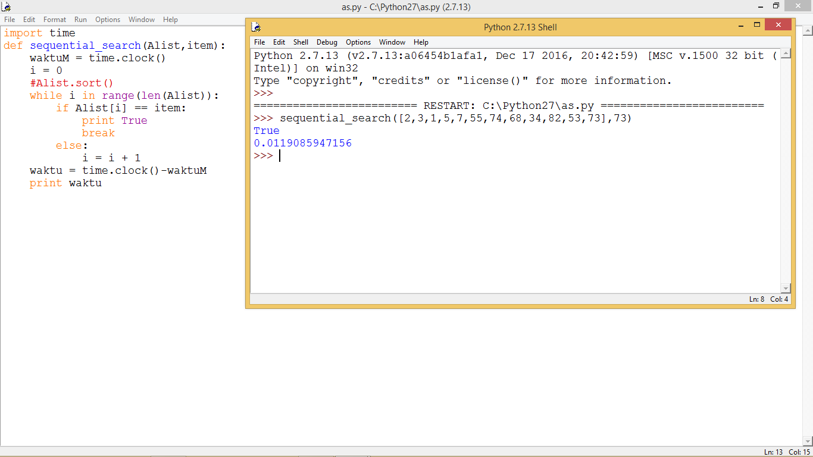

Sequential search (sorting)

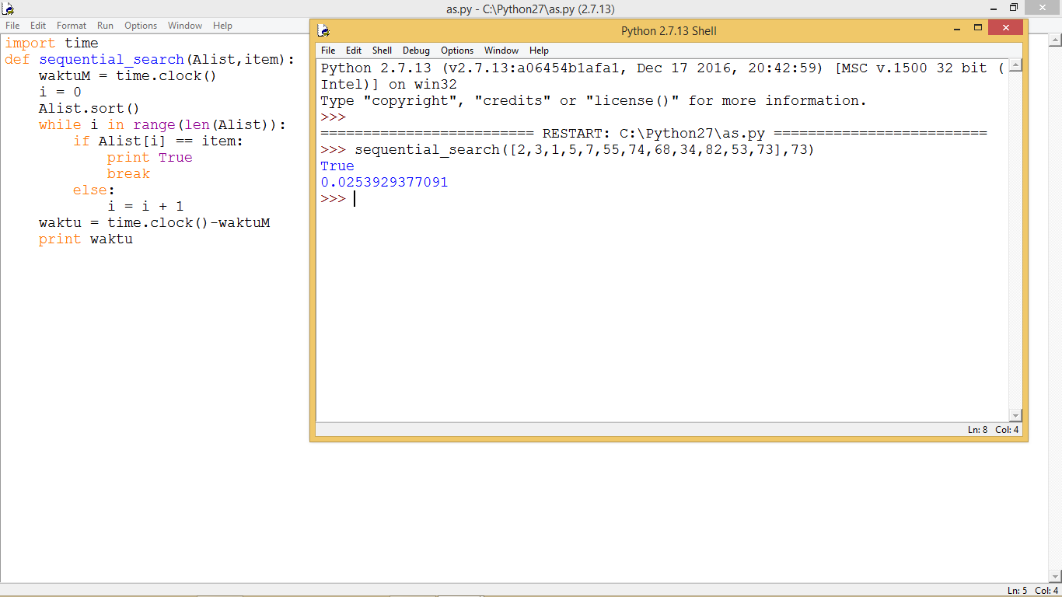

Binary searching

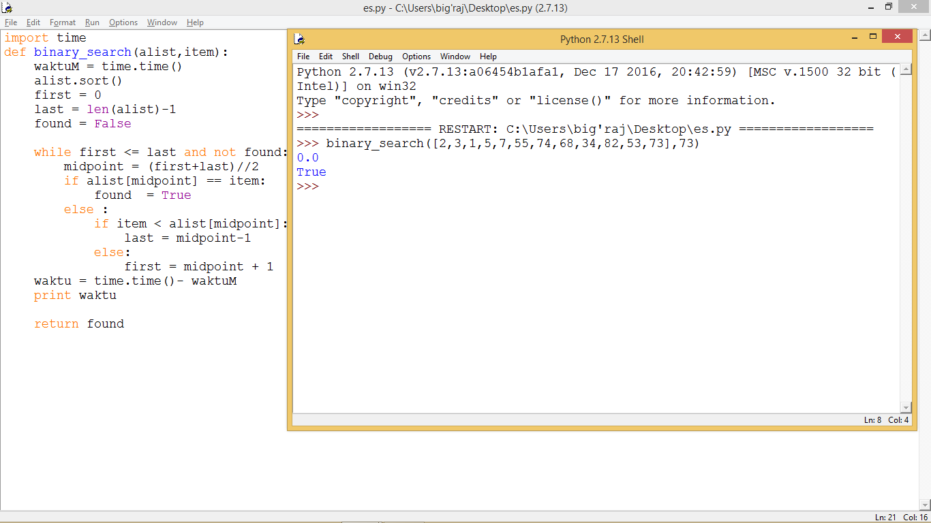

Analisis binary search